Bug Reports (Jira Style)

BUG-001
Bug Title: Incorrect product images
Environment:
- Application: Swag Labs
- Browser: Brave
- OS: Windows 10
Steps to Reproduce:
- Open Swag Labs.
- Login using problem_user / secret_sauce.
- Navigate to Products page.
- Compare product names with displayed images.
Expected Result:
Each product should display its corresponding image.
Actual Result:
Some products display incorrect images.
Screenshot Reference:
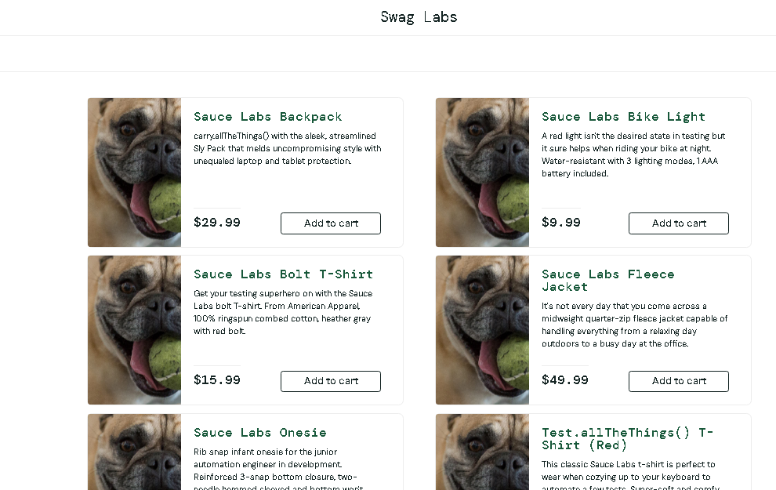
Severity: Major
Priority: P2

